PROJECT REPORT

ECHO BOT- AI CHATBOT WITH VOICE ASSISTANT

SUBMITTED BY: SHREYA, MAYANK, TUSHAR, And RAJEEV



May 9, 2025

**CERTIFICATE**

This is to certify that the project titled “Echo Bot-AI Chatbot with voice assistant” has been successfully completed by Shreya, a student of Echelon institute of technology, Faridabad, in partial fulfilment of the requirements for the award of the degree. The project has been carried out under my guidance and supervision.

MS PAYAL

ACKNOWLEDGMENT

I express my sincere gratitude to my project guide Ms Payal for their valuable guidance, support, and encouragement throughout the development of this project. I also thank all my faculty members and friends who contributed their time and advice, helping me bring this project to life.

**ABSTRACT**

Echo Bot is a simple, intelligent AI-based chatbot with an integrated voice assistant, developed using HTML, CSS, JavaScript, and Python. It provides a seamless interaction experience to users through text and voice commands. The chatbot is capable of understanding voice input, converting it into text using Speech Recognition, and responding with appropriate replies.

The project demonstrates the integration of web UI with JavaScript-based AI logic, allowing users to interact naturally using both voice and text. Echo Bot serves as a beginner friendly AI application and highlights the potential of conversational AI systems.

**INTRODUCTION**

The rapid advancement of Artificial Intelligence has brought significant improvements in human-computer interactions. Echo Bot is an attempt to explore this area by creating a voice-enabled chatbot. It is a web-based AI assistant that simulates conversations and responds using pre-defined logic.

This project uses Speech Recognition APIs, JavaScript DOM manipulation, and basic Python logic (if extended) to create an interactive chatbot that responds to user input with voice and text.

**OBJECTIVES**

To create a voice-enabled chatbot using web technologies.

* To demonstrate how voice recognition can be integrated into a web application.
* To build a smart assistant that can simulate basic AI-based conversations.

**TECHNLOGY STACK**

* + - Frontend: HTML, CSS
* Logic & Interactivity: JavaScript
* Voice Recognition: Web Speech API (Speech Recognition in JS)
* (Optional Backend/Extension): Python for advanced NLP (Natural Language Processing)

**SYSTEM ARCHITECTURE**

User --> Microphone Input --> Speech Recognition (Web Speech API)

--> Text Converted --> JavaScript Logic (Echo Bot AI)

--> Bot Response --> Display on Screen + Speak via SpeechSynthesis

**MODULES DESCRIPTION**

1. User Interface (HTML/CSS):

- Simple chat interface.

- Input field, send button, and voice button.

2. Speech Recognition (JavaScript):

- Listens to user's voice input.

- Converts speech to text using the browser's Web Speech API.

3. Bot Logic (JavaScript):

- Processes the user's input.

- Responds with relevant text.

- Speaks the response using the Speech Synthesis API.

**SCREENSHOT**

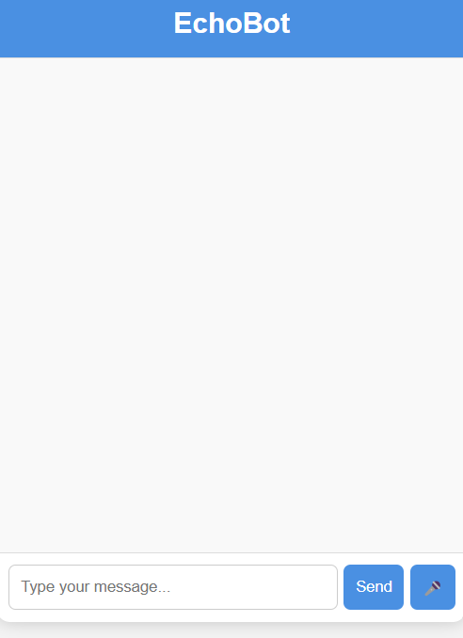

**TESTING**

* The chatbot was tested with various input phrases.
* The voice recognition works well on supported browsers (like chrome).
* Responses are quick and clear both in text and voice.

**CONCLUSION**

Echo Bot successfully demonstrates how a simple AI chatbot with voice interaction can be developed using web technologies. It allows users to communicate naturally and interactively. The project provides a strong foundation for more advanced chatbot systems with enhanced NLP.

**FUTURE SCOPE**

- Integrate advanced NLP using Python libraries like NLTK or spa Cy.

- Connect the bot to a backend server for dynamic responses.

- Store chat history using databases.

- Deploy it as a mobile app using React Native or Android Studio.

**REFERENCES**

# MDN Web Docs: <https://developer.mozilla.org/>

# W3Schools: <https://www.w3schools.com>

# Web Speech API Docs

# GitHub (for open-source chatbot examples)